**Changes according to the feedback**

For the prototype that has been created for the finance manager, I have got the first user feedback from the customer. There were some changes that has been mentioned to done in the prototype.

Below are the results of the feedback form.

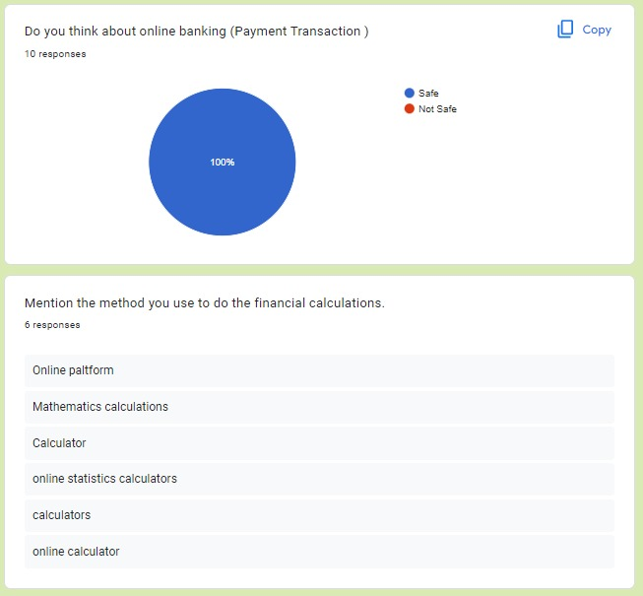

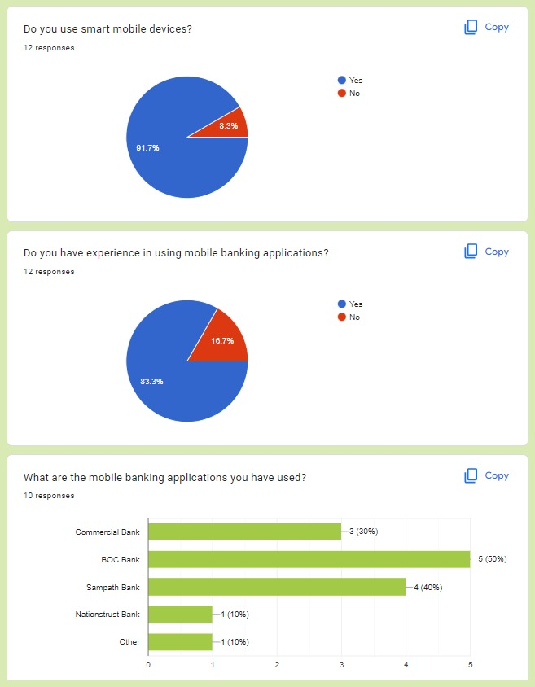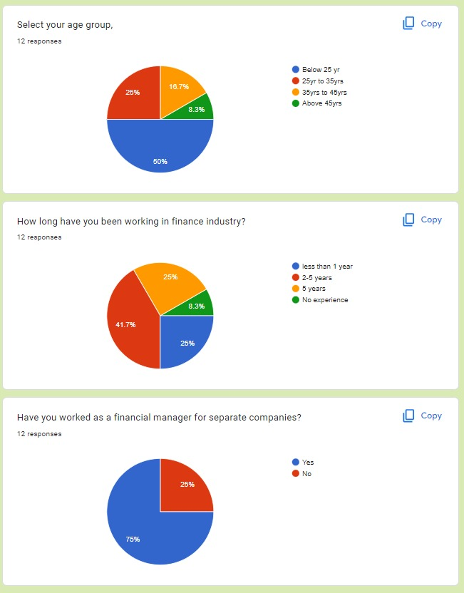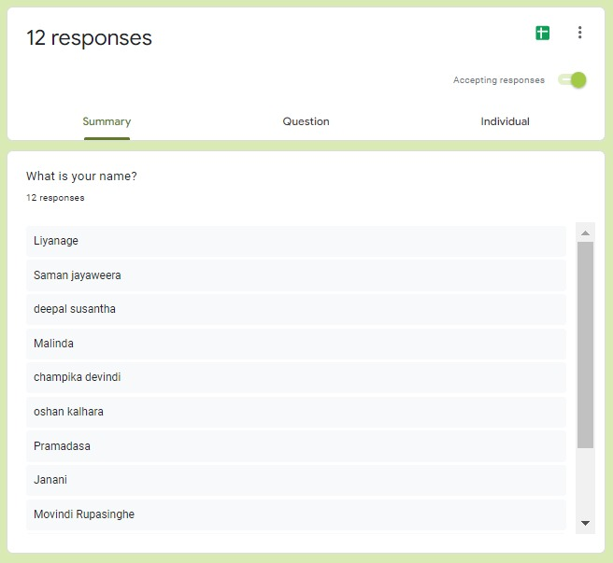

Several changes have been arise at the feedback process.

They are,

* Remove Sign up flow
* remove sign up button from the Login page
* Remove whole Login page and make enter pin page as login to make flow easy
* make changes in the front size
* make changes in the button color
* minimize report page content
* Add topics to the pages
* Remove get started page

The previous version of the prototype,

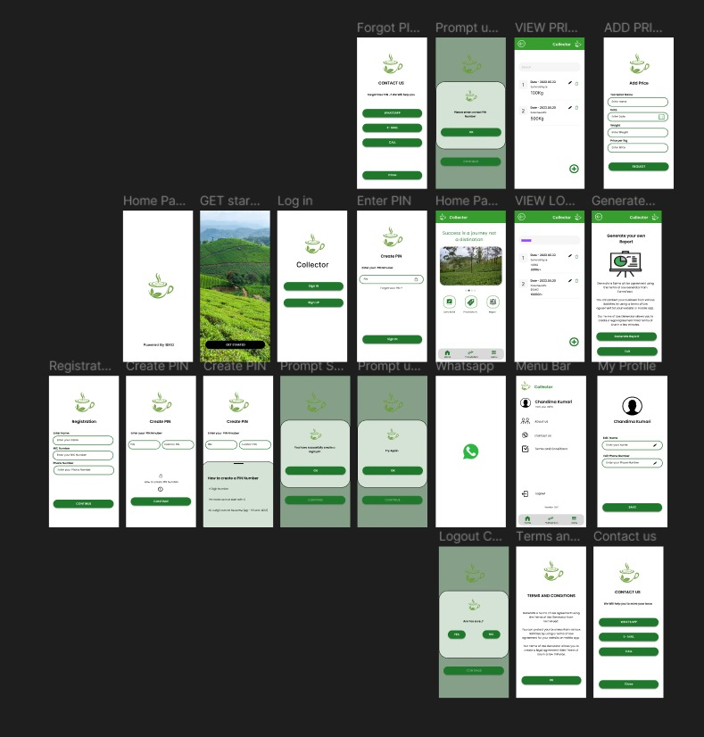

Figure - old version of prototype

The changed prototype,

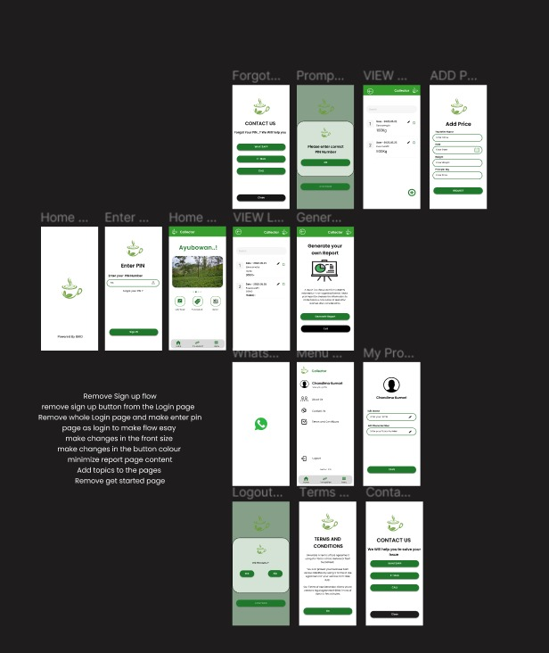

Figure - Changed version of prototype

User feedback video link- <https://drive.google.com/drive/folders/1FKCCYcVwC2kFkmioo13QoEBiZvCssnNx?usp=sharing>